Registration for the Korea-UK Workshop on Tidal Energy Collaboration

Please fill in the requested information below and contact Junsun Hwang at the British Embassy Seoul (Tel: 02 3210 5509, Email: Junsun.Hwang@fco.gov.uk) no later than Friday 27 February.

If you will be unable to attend and wish to recommend a colleague to come in your place or if you have colleagues at your organisation that would also be interested in attending, please provide their contact information here or ask them to register separately for the workshop.

Name - English
Name - Korean
Title (Prof, Dr, Mr, Ms, etc.)
Position
Organisation
Tel:
Email:

Workshop Attendance | Yes | No
Monday 9 March – Workshop Day One
Monday 9 March – Networking Reception
Tuesday 10 March – Workshop Day Two
Tuesday 10 March – Technical Visit to Shihwa Tidal Barrage

Directions to the British Embassy Seoul

Please note that car parking is not available on the grounds of the British Embassy.

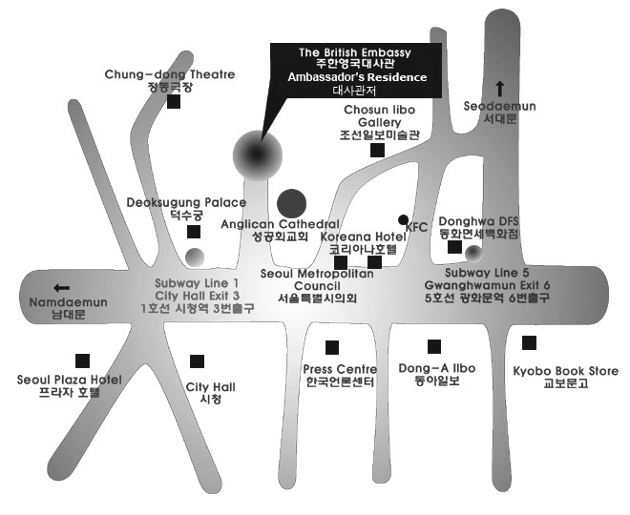

Closest Seoul Metro Station: City Hall (Line 1, Line 2), Exit 3

