Article Editing Guideline for
DigiCon Track2 Review Paper
Jone Doe, Jonathan Smith Jr., and Jane M. Doe
Abstract—These instructions give you guidelines for preparing papers for the Journal of Contents Computing (JCC) of the K-DCS or Platform Technology Letters (PTL) of the ICRP. Use this document as a template if you are using Microsoft Word 6.0 or later. Otherwise, use this document as an instruction set. Please note that use of this template is meant to assist authors in correctly formatting manuscripts for final submission and does not guarantee how the final paper will be formatted by the JCC editorial office. This template may be used for initial submissions; however, please consult the author submission guidelines for formatting instructions as most journals prefer single column format for peer review. An abstract should be 100 to 200 words and should clearly state the nature and significance of the paper. Abstracts must not include mathematical expressions or bibliographic references.
[Acknowledgements] This work was supported in part by a grant from XYZ.
Research Keywords—Keywords should closely reflect the topic and should optimally characterize the paper. Please use about four key words or phrases in alphabetical order, separated by commas.
2024-2025 © K-DCS and ICRP. Published by K-DCS and ICRP
————————————————
- J. Doe is with the National Institute of Standards and Technology, Boulder, CO 80305. E-mail: author@ boulder.nist.gov.
- J. Smith Jr. is with the Department of Physics, Colorado State University, Fort Collins, CO 80523. E-mail: author@colostate.edu.
- J. M. Doe (corresponding author) is with the Electrical Engineering Department, University of Colorado, Boulder, CO 80309. On leave from the National Research Institute for Metals, Tsukuba, Japan E-mail: author@nrim.go.jp.

Please note that all acknowledgments should not be placed in this affiliation box, but at the end of the paper, before the bibliography.
―――――――――――――――――――――――――――――――――――――――――――――――――――――――――

1 Introduction
Briefly summarize the problems, some of the reasons why they are worthwhile problems, and perhaps give an overview of your main contributions.
When you open the document, select “Page Layout” from the “View” menu in the menu bar (View | Page Layout), which allows you to see the footnotes. Then type over sections of the document or cut and paste from another document and then use markup styles. Please keep the template at 8.5” x 11”—do not set the template for A4 paper. The pull-down style menu is at the left of the Formatting Toolbar at the top of your Word window (for example, the style at this point in the document is “Text”). Highlight a section that you want to designate with a certain style, and then select the appropriate name on the style menu. The style will adjust your fonts and line spacing. Use italics for emphasis; do not underline. Do not change the font sizes or line spacing to squeeze more text into a limited number of pages. Please be certain to follow all submission guidelines when formatting an article or it will be returned for reformatting.
To insert images in Word, position the cursor at the insertion point and either use Insert | Picture | From File or copy the image to the Windows clipboard and then Edit | Paste Special | Picture (with “Float over text” unchecked).
The JCC editorial office will edit and complete the final formatting of your paper.

2 Related Work or Literature Review
This section may include the review of the state of the art in related work and literature.

3 Concept, Model and Methodology
This section should describe the concepts or the meth-odologies for solving the scientific questions or problems.

3.1 Concept…
This subsection should describe the concepts or the meth-odologies for solving a scientific questions or problems.

3.2 Methodology…
This subsection should describe the concepts or the meth-odologies for solving a scientific questions or problems.

4 Experimentes, Simulations, and/or Analyses
This section should provide convince the examiners that you answered the question or solved the problem. And show what you did that is relevant to answering the question or solving the problem.
This section can be devided into two sections; one is experiments and/or simulation section, and the other is analyses one.

5 Conclusions
Please, write conclusions that briefly summarize your contributions and provide a sense of closure.

Acknowledgment
The authors wish to thank A, B, C. This work was supported in part by a grant from XYZ.

References
- J.S. Bridle, “Probabilistic Interpretation of Feedforward Classification Network Outputs, with Relationships to Statistical Pattern Recognition,” Neurocomputing—Algorithms, Architectures and Applications, F. Fogelman-Soulie and J. Herault, eds., NATO ASI Series F68, Berlin: Springer-Verlag, pp. 227-236, 1989. (Book style with paper title and editor)
- W.-K. Chen, Linear Networks and Systems. Belmont, Calif.: Wadsworth, pp. 123-135, 1993. (Book style)
- H. Poor, “A Hypertext History of Multiuser Dimensions,” MUD History, http://www.ccs.neu.edu/home/pb/mud-history.html. 1986. (URL link *include year)
- K. Elissa, “An Overview of Decision Theory," unpublished. (Unpublished manuscript)
- R. Nicole, "The Last Word on Decision Theory," J. Computer Vision, submitted for publication. (Pending publication)
- C. J. Kaufman, Rocky Mountain Research Laboratories, Boulder, Colo., personal communication, 1992. (Personal communication)
- D.S. Coming and O.G. Staadt, "Velocity-Aligned Discrete Oriented Polytopes for Dynamic Collision Detection," IEEE Trans. Visualization and Computer Graphics, vol. 14, no. 1, pp. 1-12, Jan/Feb 2008, doi:10.1109/TVCG.2007.70405. (IEEE Transactions )
- S.P. Bingulac, “On the Compatibility of Adaptive Controllers,” Proc. Fourth Ann. Allerton Conf. Circuits and Systems Theory, pp. 8-16, 1994. (Conference proceedings)
- H. Goto, Y. Hasegawa, and M. Tanaka, “Efficient Scheduling Focusing on the Duality of MPL Representation,” Proc. IEEE Symp. Computational Intelligence in Scheduling (SCIS ’07), pp. 57-64, Apr. 2007, doi:10.1109/SCIS.2007.367670. (Conference proceedings)
- J. Williams, “Narrow-Band Analyzer,” PhD dissertation, Dept. of Electrical Eng., Harvard Univ., Cambridge, Mass., 1993. (Thesis or dissertation)
- E.E. Reber, R.L. Michell, and C.J. Carter, “Oxygen Absorption in the Earth’s Atmosphere,” Technical Report TR-0200 (420-46)-3, Aerospace Corp., Los Angeles, Calif., Nov. 1988. (Technical report with report number)
- L. Hubert and P. Arabie, “Comparing Partitions,” J. Classification, vol. 2, no. 4, pp. 193-218, Apr. 1985. (Journal or magazine citation)
- R.J. Vidmar, “On the Use of Atmospheric Plasmas as Electromagnetic Reflectors,” IEEE Trans. Plasma Science, vol. 21, no. 3, pp. 876-880, available at http://www.halcyon.com/pub/journals/21ps03-vidmar, Aug. 1992. (URL for Transaction, journal, or magzine)
- J.M.P. Martinez, R.B. Llavori, M.J.A. Cabo, and T.B. Pedersen, "Integrating Data Warehouses with Web Data: A Survey," IEEE Trans. Knowledge and Data Eng., preprint, 21 Dec. 2007, doi:10.1109/TKDE.2007.190746.(PrePrint)

First A. Author All biographies should be limited to one paragraph consisting of the following: sequentially ordered list of degrees, including years achieved; sequentially ordered places of employ concluding with current employment; association with any official journals or conferences; major professional and/or academic achievements, i.e., best paper awards, research grants, etc.; any publication information (number of papers and titles of books published); current research interests; association with any professional associations. Author membership information, e.g., is a member of the ICTPS and ICRP, if applicable, is noted at the end of the biography.

Second B. Author Jr. biography appears here.

Third C. Author biography appears here.

Helpful Hints

1 Citations
The Journal style is to note citations in individual brackets, followed by a comma, e.g. “[1], [5]” (as opposed to the more common “[1, 5]” form.) Citation ranges should be formatted as follows: [1], [2], [3], [4] (as opposed to [1]-[4], which is not JCC style). When citing a section in a book, please give the relevant page numbers [2]. In sentences, refer simply to the reference number, as in [3]. Do not use “Ref. [3]” or “reference [3]” At the beginning of a sentence use the author names instead of “Reference [3],” e.g., “Smith and Smith [3] show ... .” Please note that references will be formatted by JCC editorial office in the same order provided by the author.

2 Equations
If you are using Word, use the MathType add-on (http://www.mathtype.com) for equations in your paper (Insert | Object | Create New | Microsoft Equation or MathType Equation). “Float over text” should not be selected.
For display equations as seen below, number equations consecutively with equation numbers in parentheses flush with the right margin, as in (1). First, use the equation editor to create the equation. Then, select the “Equation” markup style. Press the tab key and write the equation number in parentheses. To make your equations more compact, you may use the solidus ( / ), the exp function, or appropriate exponents. Use parentheses to avoid ambiguities in denominators. Punctuate equations when they are part of a sentence, as in
(1)
Be sure that the symbols in your equation have been defined before the equation appears or immediately following. Italicize symbols (T might refer to temperature, but T is the unit tesla). Per equation, please refer to “(1),” not “Eq. (1)” or “equation (1),” except at the beginning of a sentence: “Equation (1) shows ... .” Also see The Handbook of Writing for the Mathematical Sciences, 1993. Published by the Society for Industrial and Applied Mathematics, this handbook provides some helpful information about math typography and other stylistic matters.
Please note that math equations might need to be reformatted from the original submission for page layout reasons. This includes the possibility that some in-line equations will be made display equations to create better flow in a paragraph. If display equations do not fit in the two-column format, they will also be reformatted. Authors are strongly encouraged to ensure that equations fit in the given column width.

3 Figures and Tables
Because the JCC editorial office will do the final formatting of your paper, some figures may have to be moved from where they appeared in the original submission. Figures and tables should be sized as they are to appear in print. Figures or tables not correctly sized will be returned to the author for reformatting.
We strongly encourage authors to carefully review the material posted here to avoid problems with incorrect files or poorly formatted graphics.
Place figure captions below the figures; place table titles above the tables. Figure captions appear as left justified. Table captions are restricted to one sentence and are formatted as title case. Any additional sentence in a table caption will be formatted as a footnote below the table (see Table 1 in this document). If your figure has two parts, include the labels “(a)” and “(b)” as part of the artwork. Please verify that the figures and tables you mention in the text actually exist. Figures and tables should be called out in sequential order, as this is how they will be placed in your paper. For example, avoid referring to figure “8” in the first paragraph of the article unless figure 8 will again be referred to after the reference to figure 7. Please do not include figure captions as part of the figure. Do not put captions in “text boxes” linked to the figures. Do not put borders around the outside of your figures. Please use the abbreviation “Fig.” even at the beginning of a sentence. Do not abbreviate “Table.” Tables are numbered numerically.
JCC do not accept color images. Do not use color unless it is necessary for the proper interpretation of your figures.
Figures (graphs, charts, drawing or tables) should be named fig1.eps, fig2.ps, etc. If your figure has multiple parts, please submit as a single figure. Please do not give them descriptive names. Author photograph files should be named after the author’s LAST name. Please avoid naming files with the author’s first name or an abbreviated version of either name to avoid confusion. If a graphic is to appear in print as black and white, it should be saved and submitted as a black and white file (grayscale or bitmap.) If a graphic is to appear in color, it should be submitted as an RGB color file.
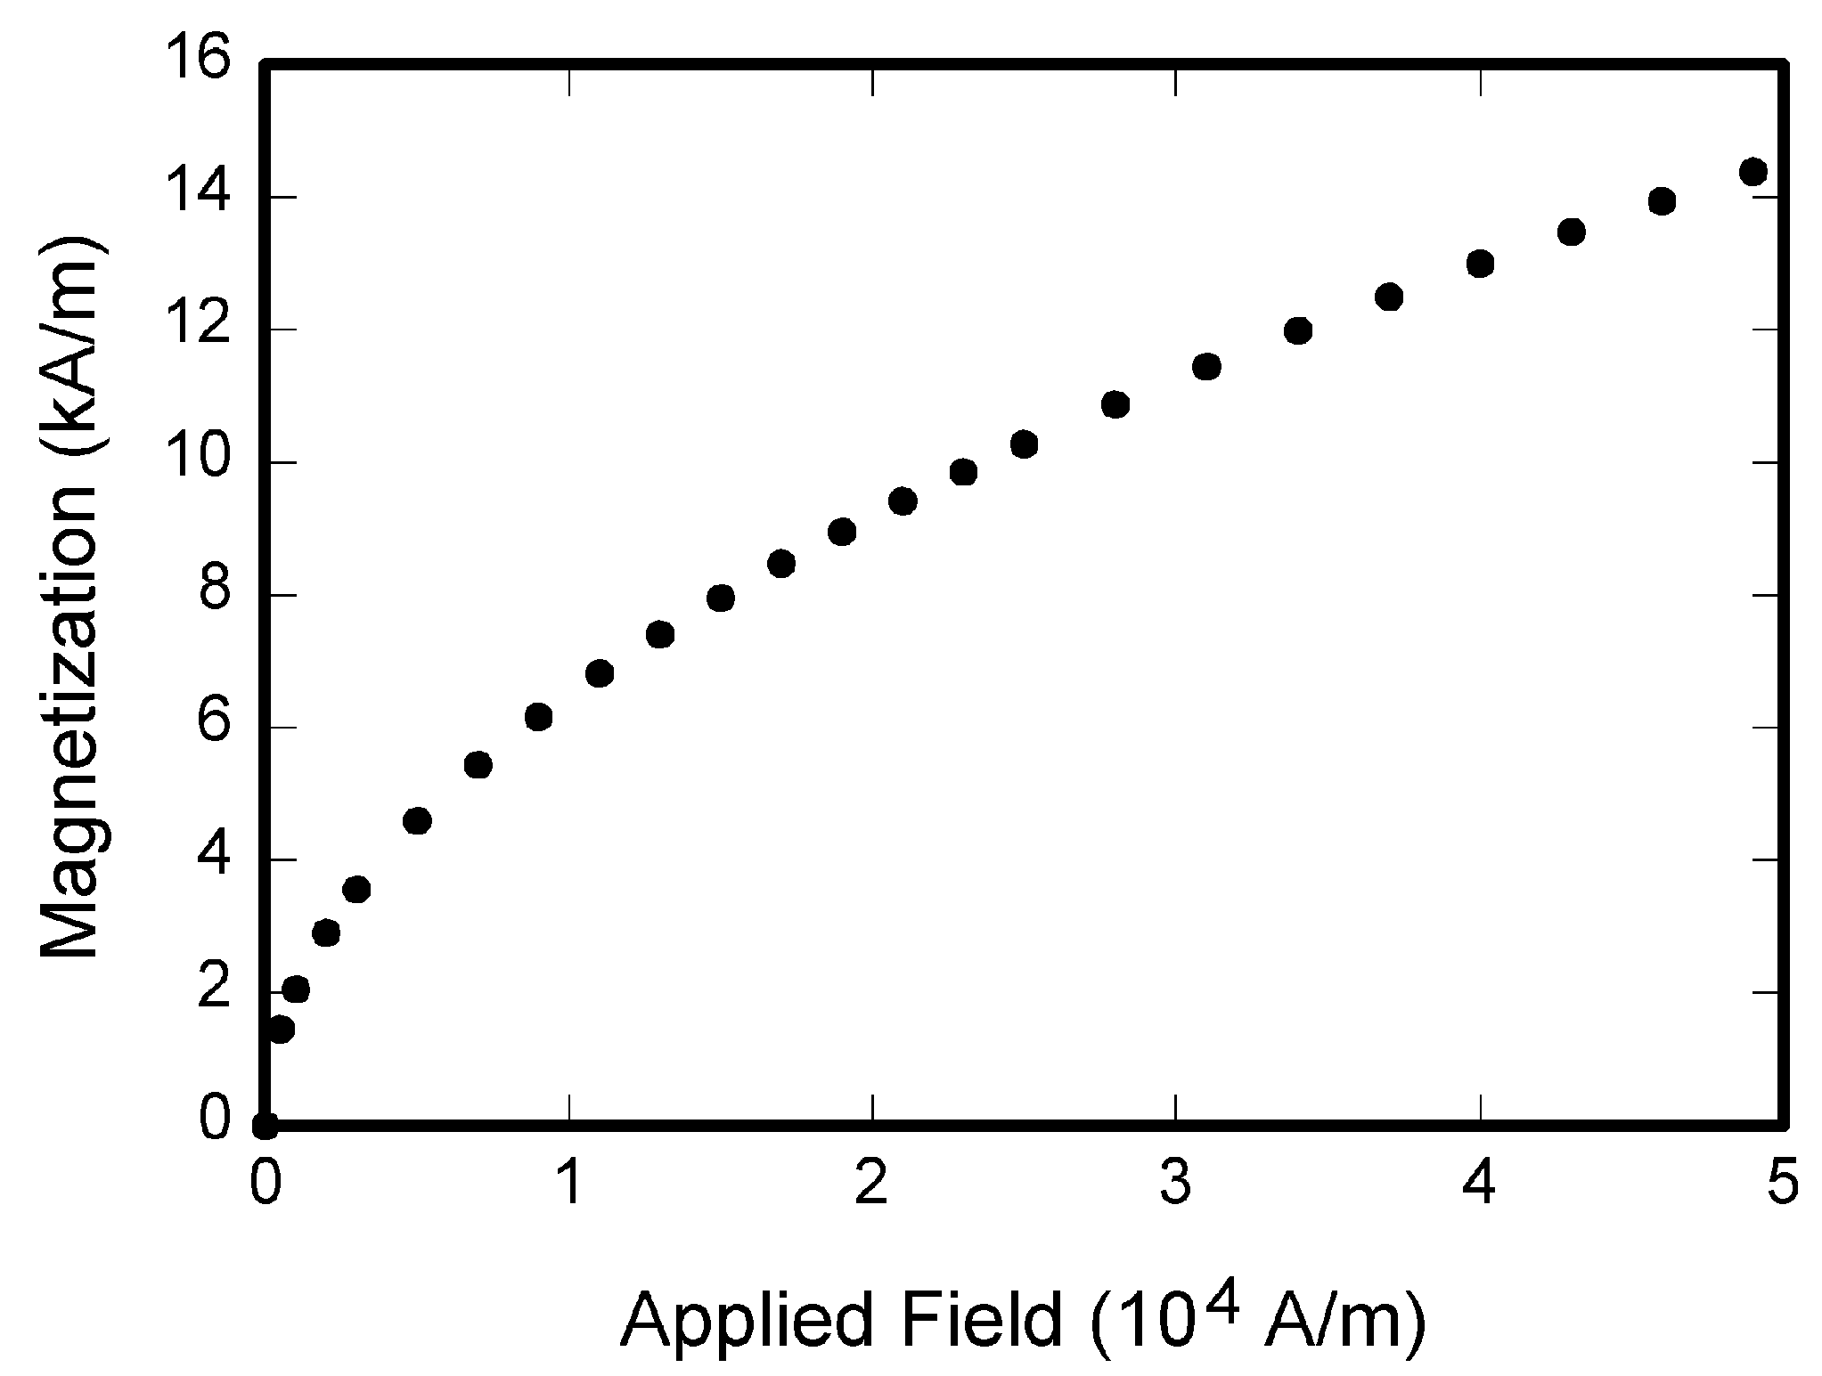
Fig. 1. Magnetization as a function of applied field. Note that “Fig.” is abbreviated. There is a period after the figure number, followed by one space. It is good practice to briefly explain the significance of the figure in the caption.
Figure axis labels are often a source of confusion. Use words rather than symbols. As an example, write the quantity “Magnetization,” or “Magnetization M,” not just “M.” Put units in parentheses. Do not label axes only with units. As in Fig. 1, for example, write “Magnetization (A/m)” or “Magnetization (Am⁻¹),” not just “A/m.” Do not label axes with a ratio of quantities and units. For example, write “Temperature (K),” not “Temperature/K.” Table 1 shows some examples of units of measure.
Multipliers can be especially confusing. Write “Magnetization (kA/m)” or “Magnetization (103 A/m).” Do not write “Magnetization (A/m) × 1,000” because the reader would not know whether the top axis label in Fig. 1 meant 16,000 A/m or 0.016 A/m. Figure labels should be legible, approximately 8 to 12 point type. When creating your graphics, especially in complex graphs and charts, please ensure that line weights are thick enough that when reproduced at print size, they will still be legible. We suggest at least 1 point.

4 Footnotes
Number footnotes separately in superscripts (Insert | Footnote). Place the actual footnote at the bottom of the column in which it is cited; do not put footnotes in the reference list (endnotes). Use letters for table footnotes (see Table 1). Please do not include footnotes in the abstract and avoid using a footnote in the first column of the article. This will cause it to appear above the affiliation box, making the layout look confusing.
Table 1. Units for Magnetic Properties
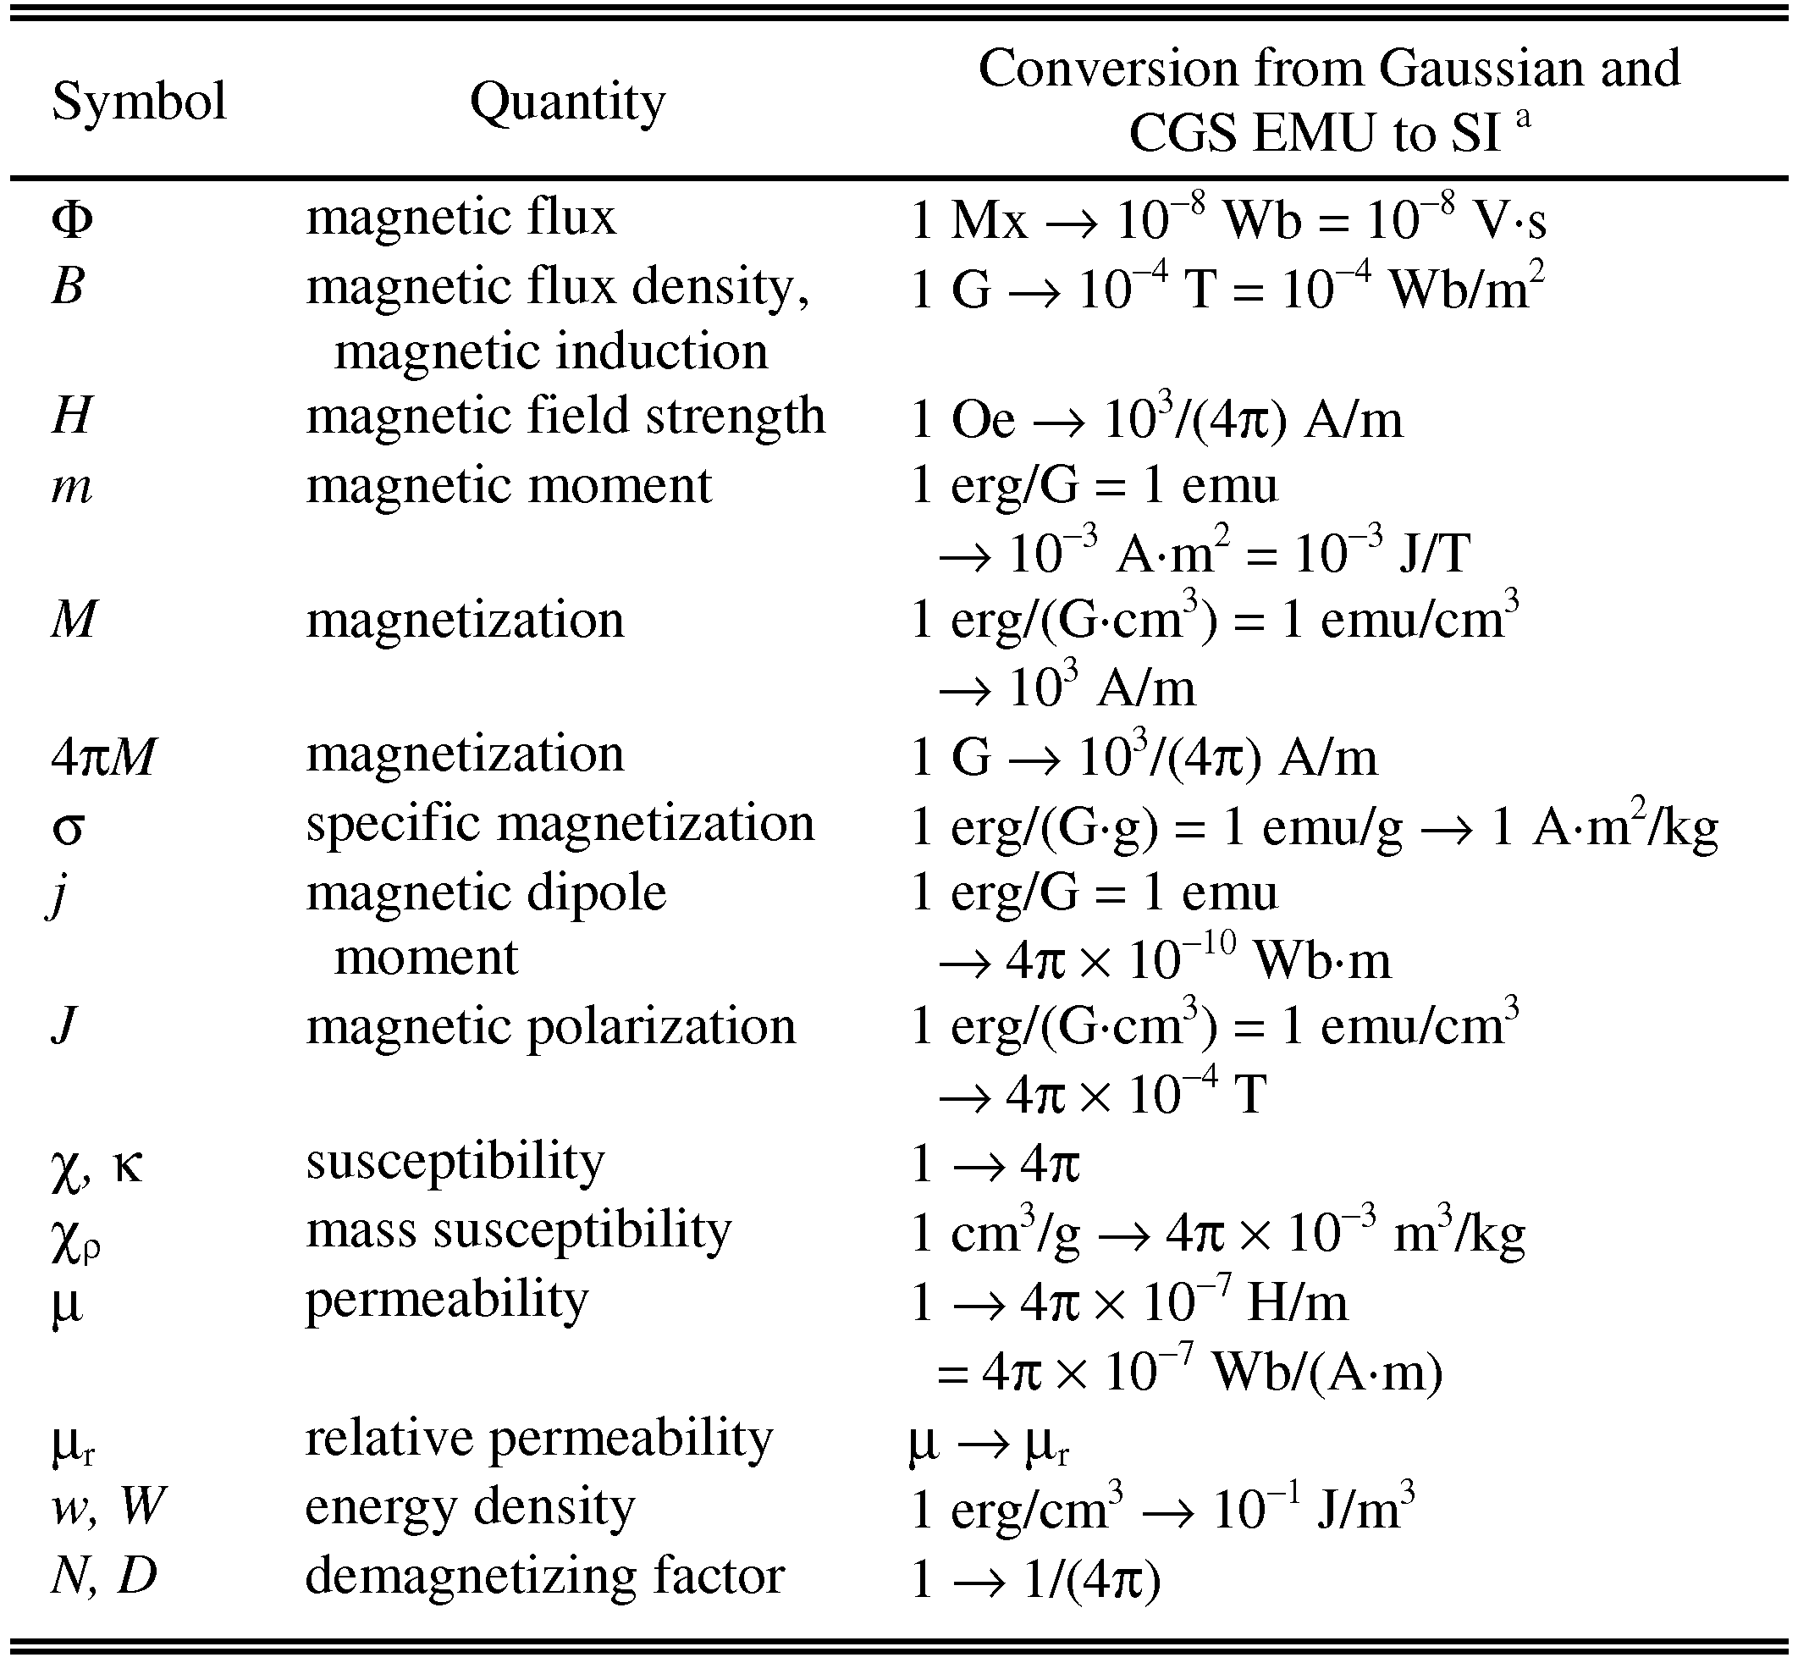
Statements that serve as captions for the entire table do not need footnote letters.
ªGaussian units are the same as cgs emu for magnetostatics; Mx = maxwell, G = gauss, Oe = oersted; Wb = weber, V = volt, s = second, T = tesla, m = meter, A = ampere, J = joule, kg = kilogram, H = henry.

5 References
Unfortunately, the document translator cannot handle automatic endnotes in Word; therefore, type the reference list at the end of the paper using the “References” style. The order in which the references are submitted in the manuscript is the order they will appear in the final paper, i.e., references submitted nonalphabetized will remain that way.
Please note that the references at the end of this document are in the preferred referencing style. Within the text, use “et al.” when referencing a source with more than three authors. In the reference section, give all authors’ names; do not use “et al.” Do not place a space between an authors' initials. Papers that have not been published should be cited as “unpublished” [4]. Papers that have been submitted or accepted for publication should be cited as “submitted for publication” [5]. Please give affiliations and addresses for personal communications [6].
Capitalize all the words in a paper title. For papers published in journals not published in English, please give the English citation first, followed by the original foreign-language citation [7].

It is recommended that footnotes be avoided (except for the unnumbered footnote with the receipt date on the first page). Instead, try to integrate the footnote information into the text.

